WEBINAR Topic: Maximizing Research Impact with AI & Big Data.
Dear Researcher,
In the era of information abundance, harnessing the power of Artificial Intelligence (AI) and Big Data is paramount for researchers seeking to make a significant impact. This session, "AI and Big Data for Maximized Research Impact," offers a dynamic exploration into the convergence of these transformative technologies and their application to research across diverse domains.
What you will learn:
- Definitions of AI and big data: Gain a comprehensive understanding of the fundamental concepts underlying AI and Big Data, including the difference between AI and machine learning algorithms, and the various levels of data analytics involving statistics, patterns and recommendations.
- What AI and big data means for research: Develop an understanding of hypothesis-driven and data-centric approach in research and learn the importance of developing data science skills to work with these evolving technologies.
- How you can utilize AI and big data: Gain an overview of how AI and big data can be applied to various stages of your research, specifically research strategy, data analysis and efficiency.
Topic name: Maximizing Research Impact with AI & Big Data
Date: 06th March 2026
Time: 1:30pm onwards (Jakarta UTC+07:00)
Duration: 90 minutes (75 minutes webinar, 15 minutes Q&A)
Registration link: https://events.teams.microsoft.com/event/6ee37b36-4137-4604-b38e-3914aa4df25e@762d8873-d777-4e7f-bb6b-e4d2cccca312

Speakers details:
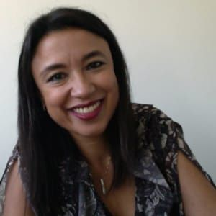
Dr. Raffaella Gozzelino
Group Leader at NOVA Medical School of Lisbon

A distinguished medical researcher and a published author, Dr. Gozzelino has 15+ years of professional expertise in the field academic writing and publishing. She has completed her Ph.D. in Cell Biology/Neurobiology from the University of Lerida, Spain, and is currently a Principal Investigator at NOVA Medical School (NMS), Lisbon, Portugal. Her dynamic career includes association with top-notch international medical journals as a peer reviewer and editor, lectureship in a number of national and international Ph.D. and Master Programs, and many other roles such as scientific advisor, Ph.D. mentor, motivational speaker and consultant.
Best regards,
Team Editage

